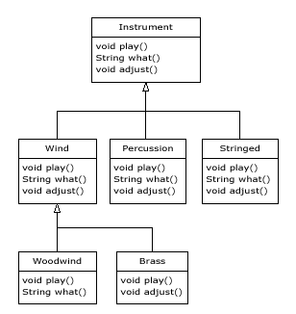
// An extensible program.

import java.util.*;

class Instrument {
public void play() {
System.out.println("Instrument.play()");
}
public String what() {
return "Instrument";
}
public void adjust() {} }

class Wind extends Instrument {
public void play() {
System.out.println("Wind.play()");
}
public String what() { return "Wind"; }
public void adjust() {}
}

class Percussion extends Instrument {
public void play() {
System.out.println("Percussion.play()");
}
public String what() { return "Percussion"; }
public void adjust() {}
}

class Stringed extends Instrument {
public void play() {
System.out.println("Stringed.play()");
}
public String what() { return "Stringed"; }
public void adjust() {}
}

class Brass extends Wind {
public void play() {
System.out.println("Brass.play()");
}
public void adjust() {
System.out.println("Brass.adjust()");
}
}

class Woodwind extends Wind {
public void play() {
System.out.println("Woodwind.play()");
}
public String what() { return "Woodwind"; }
}

public class Music3 {
// Doesn't care about type, so new types
// added to the system still work right:
static void tune(Instrument i) {
// ...
i.play();}
static void tuneAll(Instrument[] e) {
for(int i = 0; i < e.length; i++)
tune(e[i]);}
public static void main(String[] args) {
Instrument[] orchestra = new Instrument[5];
int i = 0;
// Upcasting during addition to the array:
orchestra[i++] = new Wind();
orchestra[i++] = new Percussion();
orchestra[i++] = new Stringed();
orchestra[i++] = new Brass();
orchestra[i++] = new Woodwind();
tuneAll(orchestra);
}}

